Hursh Desai, 10/17/19, Decision Models & Analytics

Motel Location for Nature’s Inn

Nature’s Inn operates a motel chain with two types of motels. Under its brand Comfort Express (CE), it offers a relatively inexpensive, spartan motel. Under its Family Suites (FS) brand, it offers a more expensive motel distinguished by various extra features. Both brands are associated with the latest ideas in green building design, attracting a segment of the customer market that is willing to let considerations of sustainability influence its purchasing decisions. Following a successful first round of expansion in the Northeast region, Nature’s Inn is planning another round of expansion, this time into the Midwest region.

Working with a real estate consultant, Nature’s Inn has identified 10 potential sites for the location of new motels. Each site can accommodate either a CE motel or an FS motel (but not both). Using historical data from the Northeast region, the consultant has estimated the net present value (NPV) of the cash flows attainable over the next 10 years at each location, with separate figures for CE and FS.

The consultant has also carried out a survey to explore the extent to which demand might be affected when two motels are located in close proximity. The first finding was that CE customers and FS customers are different segments, for the most part, and little crossover demand occurs. On the other hand, within CE and FS segments, competition occurs when motels are located too close to each other. The data suggest that competition becomes an economic factor for CE motels when they are located within 30 miles of each other and for FS motels within 40 miles of each other. Nature’s Inn has therefore decided to respect these distances in their choice of locations: In the Midwest, CE motels will not be located within 30 miles of each other, and FS motels will not be located within 40 miles of each other. The results of the consultant’s work are summarized in Exhibit 6.1.

The task for Nature’s Inn is now to develop a location plan for its Midwest expansion.

**Conclusion and Recommendation**

Nature’s Inn can maximize their NPV by build CE or FS motels using this strategy:

|  |  |  |
| --- | --- | --- |
| **Location** | **Build CE** | **Build FS** |
| 1 | YES | NO |
| 2 | NO | YES |
| 3 | NO | YES |
| 4 | YES | NO |
| 5 | NO | YES |
| 6 | NO | YES |
| 7 | YES | NO |
| 8 | NO | NO |
| 9 | YES | NO |
| 10 | NO | YES |

With this location strategy they can have a profit of $98.769 million dollars.

**Managerial Problem Definition**

Decisions to be made – if and where to build a CE or FS motel given the NPVs

Objective – maximize the profits of Nature’s Inn

Restrictions – you cannot build 2 motels in the same location and a CE motel cannot be within 30 miles of each other and a FS motel cannot be within 40 miles of each other.

**Model Formulation**

Decision Variables:

x1: whether to build a CE motel in location 1

x2: whether to build a CE motel in location 2

x3: whether to build a CE motel in location 3

x4: whether to build a CE motel in location 4

x5: whether to build a CE motel in location 5

x6: whether to build a CE motel in location 6

x7: whether to build a CE motel in location 7

x8: whether to build a CE motel in location 8

x9: whether to build a CE motel in location 9

x10: whether to build a CE motel in location 10

y1: whether to build a FS motel in location 1

y2: whether to build a FS motel in location 2

y3: whether to build a FS motel in location 3

y4: whether to build a FS motel in location 4

y5: whether to build a FS motel in location 5

y6: whether to build a FS motel in location 6

y7: whether to build a FS motel in location 7

y8: whether to build a FS motel in location 8

y9: whether to build a FS motel in location 9

y10: whether to build a FS motel in location 10

Objective Function:

Maximize: (x1 * 10.147+ x2 * 12.191 + x3 * 13.359 + x4 * 9.344 + x5 * 11.388 + x6 * 6.935 + x7 * 12.629 + x8 * 13.505 + x9 * 9.344 + x10 * 8.249) + (y1 * 11.899 + y2 * 11.242 + y3 * 10.731 + y4 * 7.519 + y5 * 14.235 + y6 * 9.636 + y7 * 8.687 + y8 * 10.293+ y9 * 9.709 + y10 * 11.461)

Constraints:

x1 +y1 , x2 +y2 , x3 +y3 , x4 +y4 , x5 +y5 , x6 +y6 , x7+y7 , x8 +y8, x9 +y9, x10 +y10 <= 1

x1 +x2 , x3 +x4 , x6 +x9 , x7 +x8 , x7 +x10 , x8 +x9 , x8+x10 , x9 +x10 <= 1

y1 +y2 , y1 +y7 , y3 +y4 , y4 +y5 , y6 +y8 , y6 +y9 , y7+y8 , y7 +y10, y8 +y9, y8 +y10, y9 +y10 <= 1

**Solution Methodology**

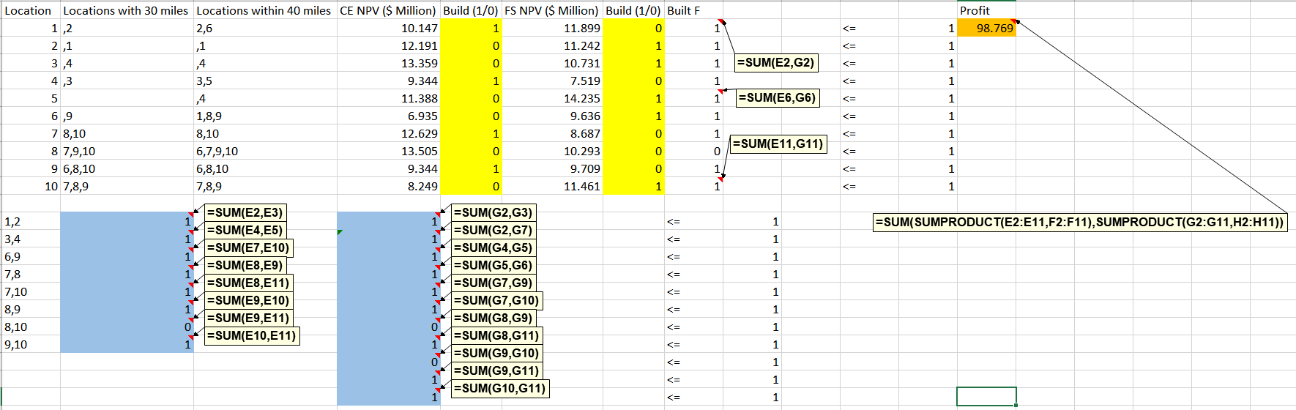

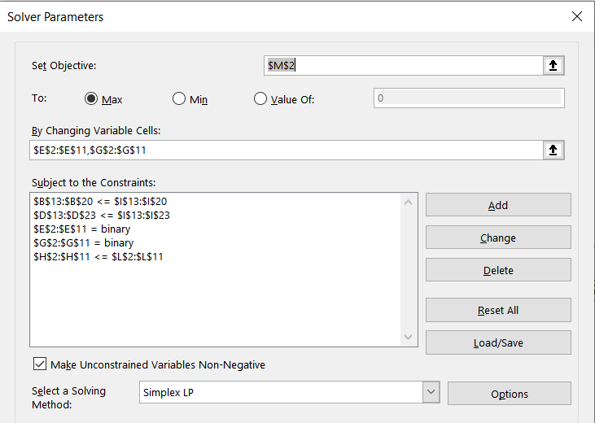

I also had to change the Integer Optimality (%) down to 0.